Noise Fundamental Lab Report

**Abstract**

This experiment is intended to explore the Johnson noise dependence on resistance, bandwidth, and temperature. In other words, we want to verify the equation <*V*J 2(*t*)> = 4kBRTΔf, by verifying that <*V*J 2(*t*)> has linear relationship with R, T, Δf respectively. The experiment result indicates that <*V*J 2(*t*)> is very close to linearly dependent on R, T, and Δf. However, the theoretical predicted value that is used to indicate linearity is slightly out of the error range of experiment measured value. Thus this experiment technically doesn’t successfully confirm the equation <*V*J 2(*t*)> = 4kBRTΔf. Most possible reason to this result is I failed to figure out systematic error existed in this experiment. I need some calibration procedure to improve the experiment.

**Introduction**

An unwanted signal in electrical engineering is called noise. There are many types of noise generated by different mechanics, one of the most simple and fundamental type is called ‘Johnson noise’. It is generated by resistors’ internal emf. The internal emf comes from thermodynamic fluctuation of the electrons in the resistor. We note this emf as *VJ*(*t*), and the squared mean of *VJ*(*t*) is then <*V*J 2(*t*)>. We have the following relations which can be derived by fundamental theory:

 (1)

Here *kB* is Boltzmann's constant, *T* is the absolute temperature of the resistor, and *Δf*  is the frequency bandwidth used in the measurement electronics.

**Experiment details**

In this experiment, we want to verify the equation given above. The experiment uses the following equipment:



The preamp signal contains Johnson noise produced by a test resistor, amplified by the preamp. The signal then is filtered and amplified again. Then the signal is squared and averaged over a certain time interval. We now can measure the time average voltage <Vout> by a multimeter. <Vout> and the Johnson noise have the following relationship:

 (2)

Where G1 and G2 are the gain of the preamp and main amp respectively, G1 = 600, G2 = 400. VN(t) is the noise generated by resistors in the amplifiers. To get <VN2(t)>, we use a negligible test resistor and measures the corresponding <Vout>, then using the equation above with VJ2(t)=0 to calculate <VN2(t)>.

Now that we have methods to obtain any parameter value in equation (1), we are ready to explore the relationship of the parameters. The experiment is separated by three parts, each exploring the relationship of <VJ2(t)> with one of the parameters from R, T, Δ*f*. Specifically, we want to test if the relationship is linear.

Part one, we try to find out the relation of <*V*J 2(*t*)> vs R. We find out <VN2(t)> by using a 1Ω test resistor. Then we use several different resistors with known resistance as test resistors, and measuring the corresponding <Vout> for each of them. Then we compute for <*V*J 2(*t*)>, and create the log-log plot of <*V*J 2(*t*)> vs R.

Part two, find out relation of <*V*J 2(*t*)> vs Δ*f.* We find the <VN2(t)> by the similar method, except this time we need several <VN2(t)> at different Δ*f* range. Then create log-log plots as well.

Part three, for the relation of <*V*J 2(*t*)> vs T. We need to find out <VN2(t)> at different temperatures and bandwidth. Then measure and compute the corresponding <*V*J 2(*t*)>, and create the log-log plots of <*V*J 2(*t*)> vs T.

**Results and analysis**

1. <*V*J 2(*t*)> vs R

Using a 1Ω resistor, we figured out <VN2(t)> = 6.95*10-14, with a very small error about 0.1% (assume that G1 and G2 are precise).

Log-log plots of <*V*J 2(*t*)> vs R show good linear relationships. If I include a 1MΩ resistor, the least squares fitted line has slope 0.86 ± 0.06; if we exclude a 1MΩ resistor, the fitted line has slope 0.97 ± 0.01. We can see it from the plot(see appendix) that the point of 1MΩ resistor diverges significantly from the line formed by other data points. Excluding 1M resistor makes a better linear relationship. Thus, 1MΩ resistor might be out of the suitable range of eq (1).



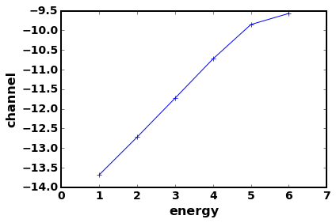 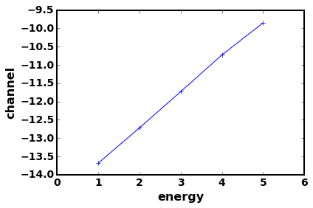



1. <*V*J 2(*t*)> vs bandwidth

In this part, I accidentally used 10Ω resistor instead of a 1Ω resistor for computing <VN2(t)>, but this shouldn’t affect the result very much, since the amplifier resistance is at thousand Ω magnitude. The experiment results at small bandwidth show weird behaviors: a 10Ω testing resistor has larger <Vout> than 10k and 100kΩ resistors, which means a small resistor creates larger John noise than large resistor. I therefore excluded theses data from the plots. Then log-log plot of <*V*J 2(*t*)> vs Δ*f* have the following results:

If using equivalent bandwidth Δ*f* as frequency bandwidth, with 10kΩ test resistor, then the fitted line has slope 1.11 ± 0.01; with 100kΩ resistor, the line has slope 1.00 ± 0.01.

10kΩ 100kΩ

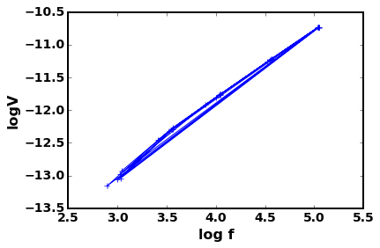 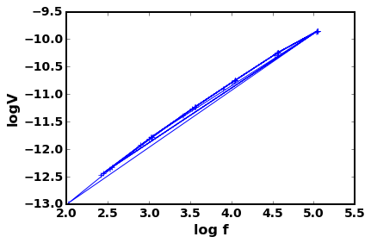

If using |f2-f1| as frequency bandwidth. With 10kΩ resistor, the fitted line has slope 1.06 ± 0.03; with 100kΩ resistor, the slope is 0.94 ± 0.02.

10kΩ 100kΩ

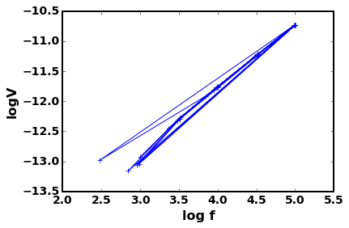 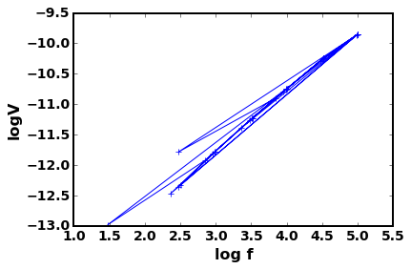

Apparently, result from equivalent bandwidth with 100kΩ resistor shows the best linear relationship. Using these data, I created a normal <*V*J 2(*t*)> vs bandwidth plot as follows, which results a slope of 1.495*10-15 ± 9*10-18, using this value I calculated the Boltzmann constant kB = 1.28*10-23 ± 2*10-25 (assume room temperature T has 1% error, and the resistance R has 1% error).

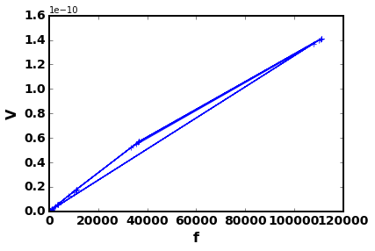

My measured Boltzmann constant differ the theoretical value by 7%, and it does not fall in the error range. I guess the weird behavior described above means there is some systematical error exist either in the equipment or my operation.

1. <*V*J 2(*t*)> vs T

Using the data I have, I created several log-log <*V*J 2(*t*)> vs T plots at different frequency bandwidth and resistance. All of them show decent linear relationships. They have slope ranging from 0.85 to 1.02 with smaller than 1% error. The average of the slopes is 0.95.

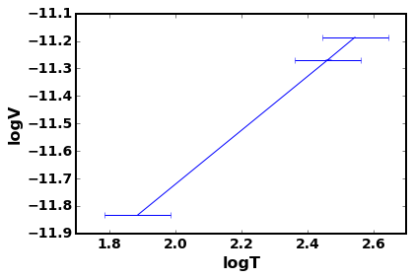

Here is the graph of log<*V*J 2(*t*)> vs logT, with 10kΩ resistor,

1 – 33 kHz frequency bandwidth. Graphs of different resistance

value and bandwidth look very similar. See appendix for all graphs.

In this part I only makes 3 different temperature situations, which makes each log-log <*V*J 2(*t*)> vs T plot only has 3 data point. More data points should give a more consistent relationship, possibly have an average slope closer to 1. To make more different temperature measurement, we can utilize the heating function of the equipment to heat the resistor at different temperature and do the measurements.

**Conclusion**

All my results show OK linear relationship of Johnson noise dependence on R, Δf, and T. The result log-log plots have slope close to 1, but unfortunately 1 does not fall in the error range of the slopes, except for <*V*J 2(*t*)> vs Δ*f.* I believe there are some undiscovered systematic errors exist in the experiment. They could from the gain value of amplifiers, also could from the square and time average module. Overall, I consider this experiment doesn’t confirm eq (1) successfully, but certainly doesn’t reject eq (1) since there exist unconsidered systematic error.

**Reference**

PHYS:3756, Intermediate Lab Manual, Noise Fundamentals, the University of Iowa.

Appendix: see attached folder

File explanation:

dataAndCalculations.xlsx: contains raw data and calculations for other values and errors.

Result.doc: contains results from python programs, mostly plots.